Test 3 Name:
Question | Answer | Work
1 | 0.4332​ | P(200<X<275)=P(Z<1.50)−P(Z<0.00)=0.9332−0.500=0.4332​
2 | 0.3811 | P(170 <= X <= 220) = P(-0.6 <= Z <= 0.4) = P(Z <= 0.4) - P(Z <= -0.6) = 0.3811
3 | 0.0643 | 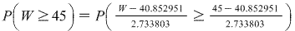=  ==  = 1- 0.9357 = 0.0643
4 | -1.75° | z-score for probability=-1.75  Z=(X-mu)/sigma  x=(mu+Z*sigma)  x=0-1*1.75  x=-1.75 degrees
5 | 0.0932 | Mean = np = 10000 * 0.02 = 200  SD= Sqrt( np(1-p))  = sqrt( 100 * 0.02 * 0.98) = 14  Using normal approximation  P( X >= x) = P( Z > x-0.5 - Mean / SD)  Hence,  P( X > 219) = P( Z > 218.5 - 200 / 14)  = P( Z > 1.3214)  = 0.0932
6 | 4.898 | = 0.84 * 0.382 + 4.577  = 4.898 million cells per microliter
7 | 0.0764 | P(X = 43) = P[ (42.5 - 45)/4.7434 < z < (43.5 - 45)/4.7434] = P[-0.527 < z < -0.316]  Using the Standard Normal table: P[-0.527 < z < -0.316] = 0.0764
8 | 0.0577 | P((119-114.8)/(13.1/root(23))<Z<(122-114.8)/(13.1/root(23))...  P(1.54<Z<2.64)  = P(2.64) - P(1.54) = 0.9959 - 0.9382 = 0.0577
9 |  | - = 8.4, = 1.8, n = 40, = 8.4  - = / n = 1.8 / 40 = 0.2846  P( < 8.9) = P(( - ) / < (8.9 - 8.4) / 0.2846)  = P(z < 1.76)  = 0.9608
10 |  | P(correctly guessing 14 or more times) = P(X 14)  = 1 - P(X < 13.5) {with continuity correction}  = 1 - P(Z < (13.5 - 10)/2.236)  = 1 - P(Z < 1.565)  = 1 - 0.9412  = 0.0582, No  Her claim is not valid. Probability of guessing 14 or more tosses correctly is greater than 0.05 and hence it cannot be considered as an unusual event.
11 |  | 3280/8200= .4  ME= 2.576* sqrt((.4*.6)/8200)= .0139
12 | 0.0404 | 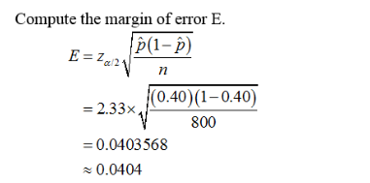
13 | 0.0323 < p<0.07 82 | 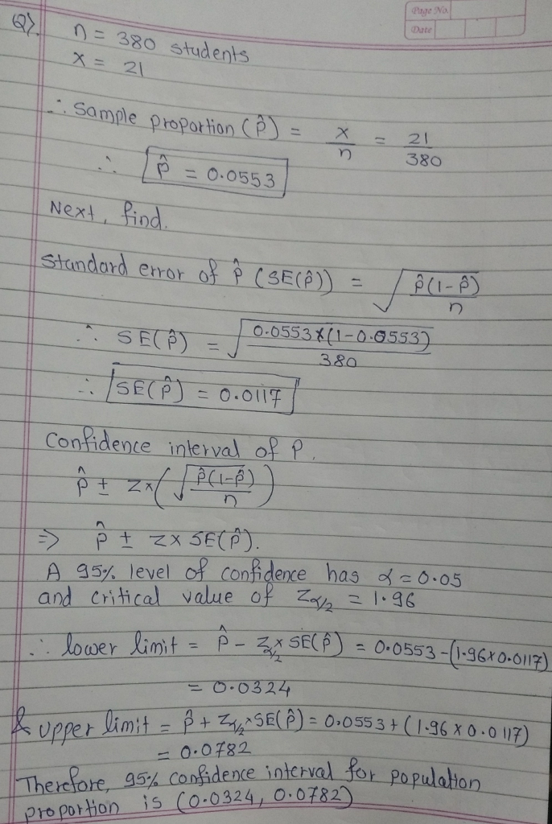
14 | 91.68 < µ < 98.32 | 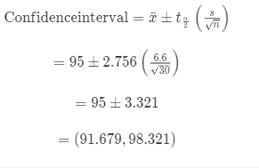
15 | 0.301<p<0.435 | 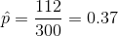  level of confidence=98 %  and  .E= Margin of error can be calculated by  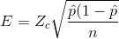  Z_{c}= ccritical z score at 98 % confidence level= 2.33  Hence E= 0.065  So Confidence interval of population proportion is  0.301<p<0.445
16 | 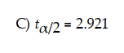 | The degree of freedom =n-1=17-1=16  Given a=1-0.99=0.01, t(0.005, df=16) =2.921
17 | (21.9%, 35.7%) | p(HBP) = 34/116 = .2931  ME = 2.326sqrt((.2931)(.7069)/116) = .0423  (21.9%, 35.7%)
18 | 223 mg < µ < 232 mg | 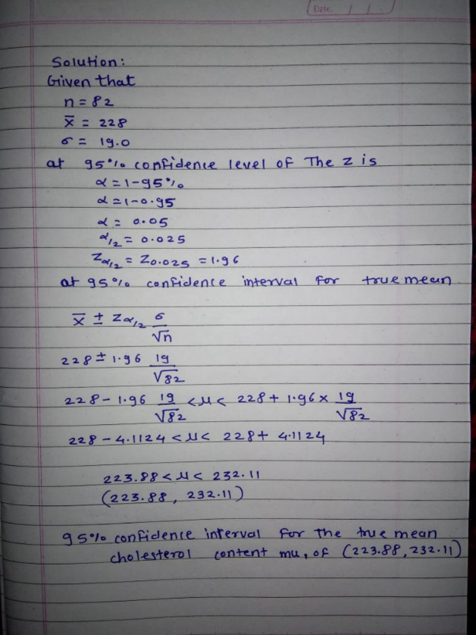
19 | =2115 | Margin error = Z(0.005) sqrt(pq/n) < 0.028  (2.576/0.028)^2 < n/pq  n > (2.576/0.028)^2*(0.25)  =2115
20 | =2.921 | The degree of freedom =n-1=17-1=16  Given a=1-0.99=0.01, t(0.005, df=16) =2.921
21 | B) decreases; decreases | B) decreases; decreases
22 | 173.8 mg < µ< 196.2 mg | 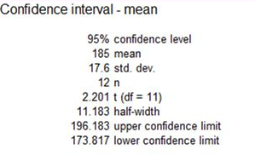
23 | 0.0184 | = 1.96 * (\sqrt((0.720 * 0.280) / 2448)  = 0.0184
24 | 1.62 | For(1−Confidencelevel)=1−0.8948  α=0.1052  α/2 = 0.1052/2  ​  =0.0526 (from the graph)  =1.62  ​
25 | 0.778<p<0.883 | 